## ER Diagram

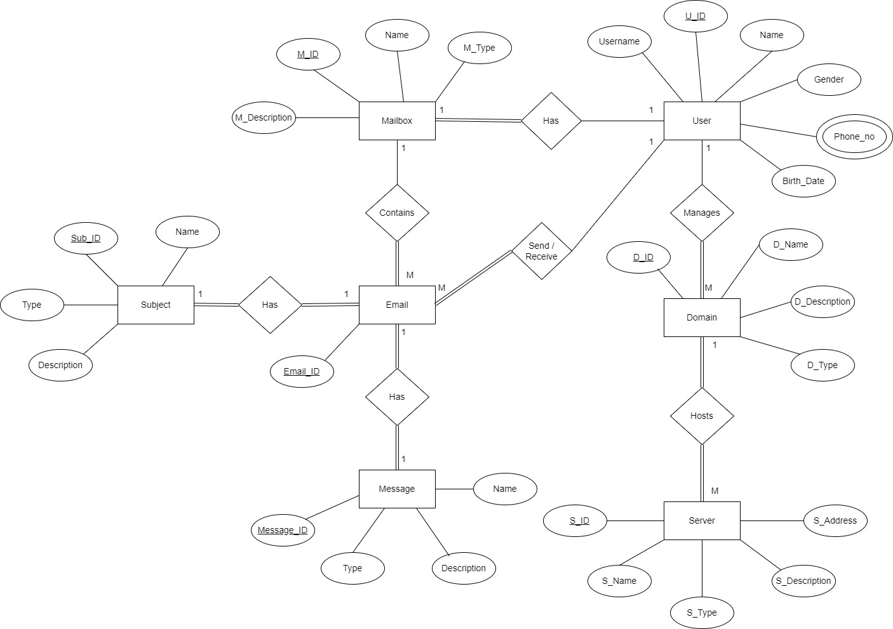

## Assumptions

**Cardinalities**

* User to Domain: One user can manage many domains (1:M), one domain belongs to one user (M:1).
* Domain to Server: One domain can be hosted on many server (1:M), one server hosts one domain (M:1).
* User to Mailbox: One user has one mailbox (1:1), one mailbox belongs to one user (1:1).
* Mailbox to Email: One mailbox contains many emails (1:M), one email belongs to one mailbox (M:1).
* User to Email (Sent): Many users can send many emails (1:M), one email is sent by one user (M:1).
* User to Email (Receive): One user can receive many emails (1:M), one email can be received by one user (M:1).
* Email to Subject: One email has one subject (1:1), one subject is linked to one email (1:1).
* Email to Message: One email has one message (1:1), one message is linked to one email (1:1).

**Participation**

* User to Domain: Partial participation for user (a user may not manage a domain), total participation for domain (every domain must be managed by a user).
* Domain to Server: Total participation for both domain (every domain must be hosted by a server) and server (every server must host a domain).
* User to Mailbox: Total participation for (every mailbox must belong to a user), partial participation for user (a user may not have a mailbox).
* Mailbox to Email: Total participation for mailbox (every mailbox contains emails), partial participation for email (an email may exist independently of a mailbox).
* User to Email (Sent): Partial participation for User (a user may not send emails), total participation for Email (every email must have a sender).
* User to Email (Receive): Partial participation for User (a user may not receive emails), total participation for Email (every email must be received by at least one user).
* Email to Subject: Total participation for both email (every email must have a subject) and subject (every subject must belong to an email).
* Email to Message: Total participation for both email (every email must have a message) and message (every message must belong to an email).

## Data Dictionary

* User Table

|  |  |  |  |  |
| --- | --- | --- | --- | --- |
| Field Name | Data Type | Field Length | Constraint | Description |
| U_ID | INT | 10 | Primary Key | Unique identifier for the user |
| Username | VARCHAR | 50 | NOT NULL, UNIQUE | Username (email address) of the user |
| Name | VARCHAR | 100 | NOTT NULL | Full name of the user |
| Gender | VARCHAR | 10 | NULLABLE | Gender of the user |
| Phone_no | VARCHAR | 15 | NULLABLE | Phone number of the user |
| Birth_Date | Date | - | NULLABLE | Birth date of the user |

* Mailbox Table

|  |  |  |  |  |
| --- | --- | --- | --- | --- |
| Field Name | Data Type | Field Length | Constraint | Description |
| M_ID | INT | 10 | Primary Key | Unique identifier for the mailbox |
| M_Type | VARCHAR | 50 | NOT NULL | Type of mailbox (Personal, Business) |
| M_Description | VARCHAR | 255 | NULLABLE | Description of the mailbox |
| Name | VARCHAR | 100 | NOT NULL | Name of the mailbox (usually same as Username) |
| U_ID | INT | 10 | Foreign Key  (User.U_ID) | Foreign key referencing User Table |

* Domain Table

|  |  |  |  |  |
| --- | --- | --- | --- | --- |
| Field Name | Data Type | Field Length | Constraint | Description |
| D_ID | INT | 10 | Primary Key | Unique identifier for the domain |
| D_Name | VARCHAR | 100 | NOT NULL | Name of the domain |
| D_Description | VARCHAR | 255 | NULLABLE | Description of the domain |
| D_Type | VARCHAR | 50 | NULLABLE | Type of domain (public, private) |
| U_ID | INT | 10 | Foreign Key  (User.U_ID) | Foreign key referencing User Table |

* Server Table

|  |  |  |  |  |
| --- | --- | --- | --- | --- |
| Field Name | Data Type | Field Length | Constraint | Description |
| S_ID | INT | 10 | Primary Key | Unique identifier for the server |
| S_Name | VARCHAR | 100 | NOT NULL | Name of the server |
| S_Description | VARCHAR | 255 | NULLABLE | Description of the server |
| S_Type | VARCHAR | 50 | NULLABLE | Type of the server |
| S_Address | VARCHAR | 100 | NULLABLE | Address or location of the server (IP address or URL) |
| D_ID | INT | 10 | Foreign Key  (Domain.D_ID) | Foreign key referencing Domain Table |

* Email Table

|  |  |  |  |  |
| --- | --- | --- | --- | --- |
| Field Name | Data Type | Field Length | Constraint | Description |
| Email_ID | INT | 10 | Primary Key | Unique identifier for the email |
| M_ID | INT | 10 | Foreign Key  (Mailbox.M_ID) | Foreign key referencing Mailbox Table |
| U_ID | INT | 10 | Foreign Key  (User.U_ID) | Foreign key referencing User Table |

* Subject Table

|  |  |  |  |  |
| --- | --- | --- | --- | --- |
| Field Name | Data Type | Field Length | Constraint | Description |
| Sub_ID | INT | 10 | Primary Key | Unique identifier for the subject |
| Name | VARCHAR | 100 | NOT NULL | Title or name of the subject |
| Description | VARCHAR | 255 | NULLABLE | Description of the subject |
| Type | VARCHAR | 50 | NULLABLE | Type or category of the subject |
| Email_ID | INT | 10 | Foreign Key  (Email.Email_ID) | Foreign key referencing Email Table |

* Message Table

|  |  |  |  |  |
| --- | --- | --- | --- | --- |
| Field Name | Data Type | Field Length | Constraint | Description |
| Message_ID | INT | 10 | Primary Key | Unique identifier for the message |
| Name | VARCHAR | 100 | NOT NULL | Title or name of the message |
| Description | VARCHAR | 255 | NULLABLE | Description of the Message |
| Type | VARCHAR | 50 | NULLABLE | Type of the message |
| Email_ID | INT | 10 | Foreign Key  (Email.Email_ID) | Foreign key referencing Email Table |

**Schema Mapping Steps**

**Step 1**

For each strong entity, create a relation with all simple attributes. Decompose composite attributes into basic ones. Exclude multi-valued /derived attributes.

User

|  |  |  |  |  |
| --- | --- | --- | --- | --- |
| U_ID | Name | Username | Gender | Birth_Date |

Mailbox

|  |  |  |  |
| --- | --- | --- | --- |
| M_ID | Name | M_Type | M_Description |

Domain

|  |  |  |  |
| --- | --- | --- | --- |
| D_ID | D_Name | D_Type | D_Description |

Server

|  |  |  |  |  |
| --- | --- | --- | --- | --- |
| S_ID | S_Name | S_Type | S_Description | S_Address |

Email

|  |
| --- |
| Email_ID |

Subject

|  |  |  |  |
| --- | --- | --- | --- |
| Sub_ID | Name | Type | Description |

Message

|  |  |  |  |
| --- | --- | --- | --- |
| Message_ID | Name | Type | Description |

**Step 2**

For each weak entity, we need to create a relation with its attributes and the primary key of all foreign keys. The primary key of the weak entity will be composed from the main objects full primary key and a partial key.

**Step 3**

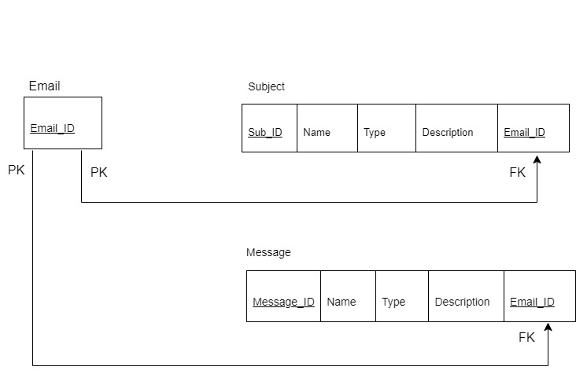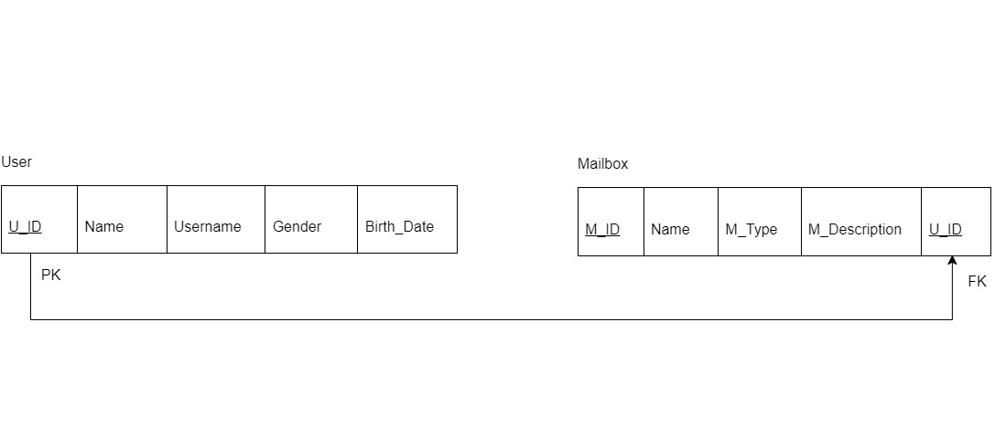For a 1:1 relationship, choose either side (preferably the entity with total participation). Set the primary key of one entity as the foreign key in the chosen entity. Include all simple attributes of the relationship as attributes in the chosen entity.

**Step 4**

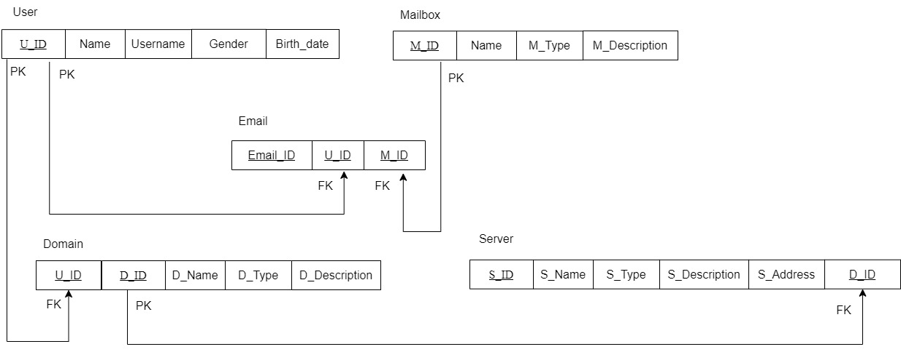For 1:M relationships, choose the "many" side and add the primary key of the "one" side as a foreign key in the "many" side. Include any attributes of the relationship in the "many" side as well.

**Step 5**

For M: N relationships, create a new relation which includes both the primary keys of entities and any attributes that describe them.

**Step 6**

For multi-valued attributes, create a new relation that includes the multi-valued attribute and the primary key of the associated entity.

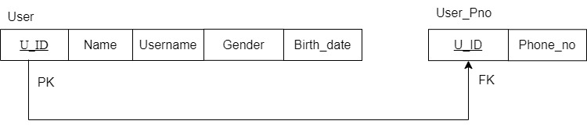

**Step 7**

For n-ary relationship types, create a new relation that includes the attributes of the relationship and the primary keys of all participating entities.

### **Complete schema**

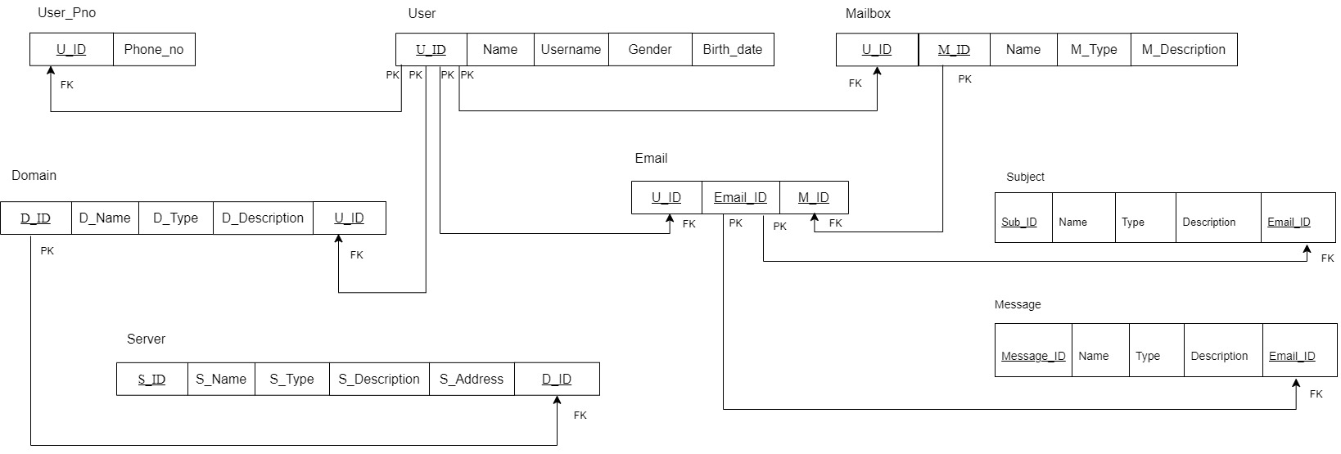

## Database Normalization

Database normalization is an essential process that should be applied to every database design. It involves taking a database design and applying a formal set of criteria and rules, known as normal forms.

Types of Database Normal Form

* 1st Normal Form (1NF)
* 2nd Normal Form (2NF)
* 3rd Normal Form (3NF)

### **1st Normal Form (1NF)**

The First Normal Form (1NF) requires that a table meets the following conditions:

* Rows are unordered.
* Columns are unordered.
* Duplicate data is allowed.
* Every row-column intersection contains a single, unique value.
* All columns contain only regular, atomic values with no hidden or grouped data.

Example:

Suppose the User table initially looks like this: (Before 1NF)

User

|  |  |  |  |  |  |
| --- | --- | --- | --- | --- | --- |
| U_ID | Name | Username | Gender | Birth_Date | Phone_no |
| 001 | Benara | Benara123 | Female | 2006-05-10 | 011 263 6055  077 222 6784 |
| 002 | Lanka | Lanka567 | Male | 2000-07-19 | 078 556 4567 |

* In this case, the Phone_no column contains multiple values in a single row.

Now the tables look like this: (in 1NF)

* Ensuring that each row contains only a single atomic value.

User

|  |  |  |  |  |  |
| --- | --- | --- | --- | --- | --- |
| U_ID | Name | Username | Gender | Birth_Date | Phone_no |
| 001 | Benara | Benara123 | Female | 2006-05-10 | 011 263 6055 |
| 001 | Benara | Benara123 | Female | 2006-05-10 | 077 222 6784 |
| 002 | Lanka | Lanka567 | Male | 2000-07-19 | 078 556 4567 |

### **2nd Normal Form (2NF)**

An entity will be in second normal form (2NF) when all of its attributes depend on the entire primary key. The reason for this is that the values in each column depend on those of other columns.

* The table must be in 1NF already and all non-key columns must depend fully on the primary key.
* These are moved to independent tables so as to remove any partial dependencies.
* Second Normal Form is an issue if there is a composite primary key composed of two or more columns

Example:

Suppose the User table initially looks like this: (Before 2NF)

User

|  |  |  |  |  |  |
| --- | --- | --- | --- | --- | --- |
| U_ID | Name | Username | Gender | Birth_Date | Phone_no |
| 001 | Benara | Benara123 | Female | 2006-05-10 | 011 263 6055 |
| 001 | Benara | Benara123 | Female | 2006-05-10 | 077 222 6784 |
| 002 | Lanka | Lanka567 | Male | 2000-07-19 | 078 556 4567 |

Now the tables look like this: (in 1NF)

* We need to ensure that all attributes depend entirely on the primary key. In this case, Phone_no depends on the U_ID, but we also need a unique identifier for each phone number, so we create a composite key using both U_ID and Phone_no.
* Here, Phone_no is fully dependent on U_ID. Since there’s no partial dependency, the table is in **2NF**.

User

|  |  |  |  |  |
| --- | --- | --- | --- | --- |
| U_ID | Name | Username | Gender | Birth_Date |
| 001 | Benara | Benara123 | Female | 2006-05-10 |
| 002 | Lanka | Lanka567 | Male | 2000-07-19 |

User_Pno

|  |  |
| --- | --- |
| U_ID | Phone_no |
| 001 | 011 263 6055 |
| 001 | 077 222 6784 |
| 002 | 078 556 4567 |

### **3rd Normal Form (3NF)**

The third normal form states that you should eliminate fields in a table that do not depend on the key.

* A table must already be in Second Normal Form (2NF).
* Non-primary key columns should not depend on other non-primary key columns.
* There should be no transitive functional dependencies.
*  This schema is already in Third Normal Form (3NF).

## Database using SQL server

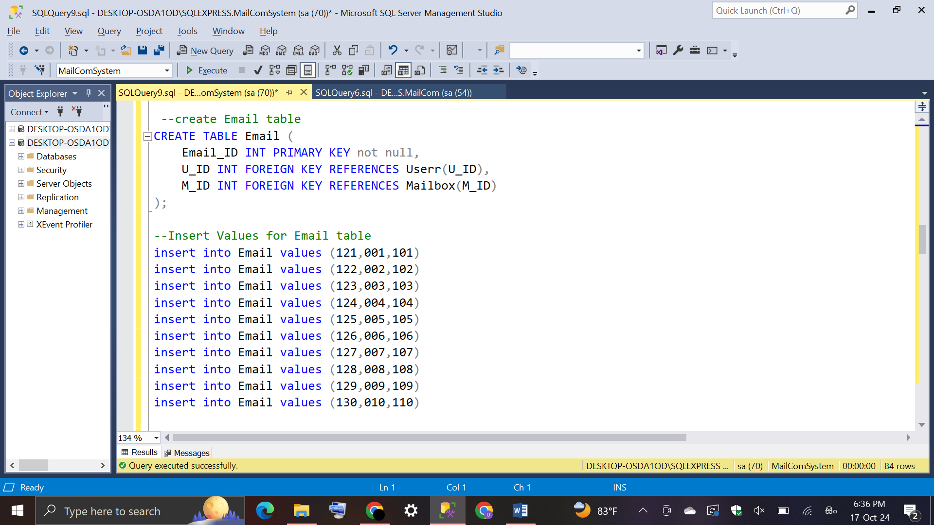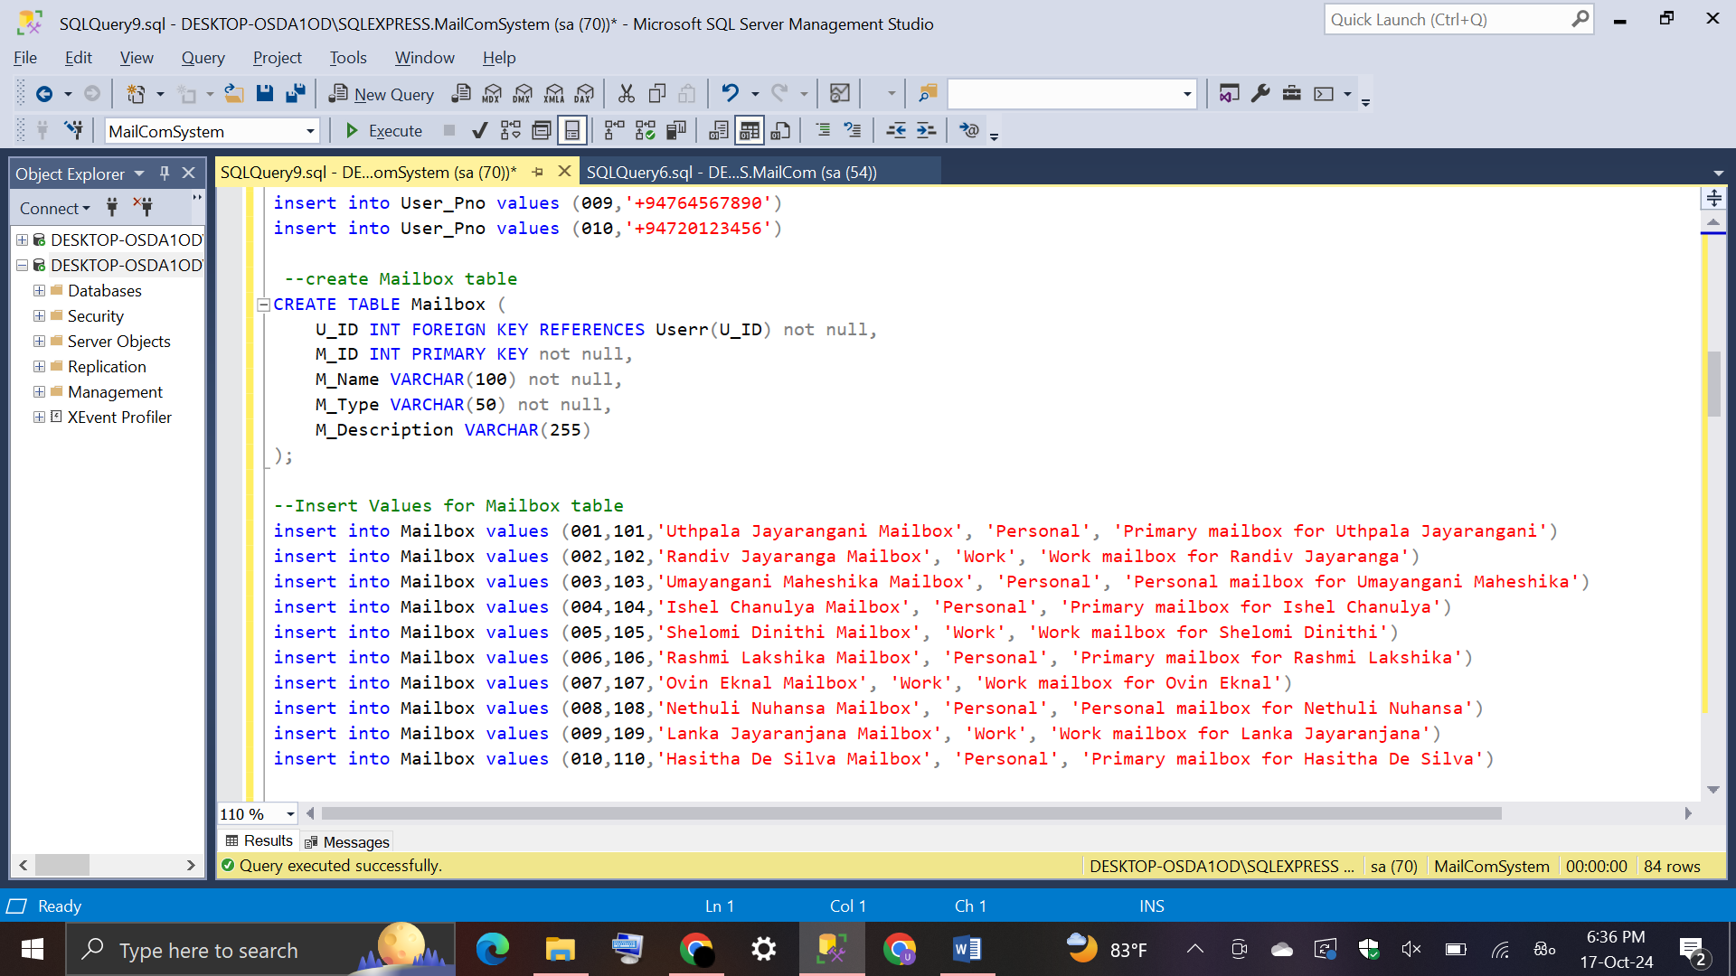

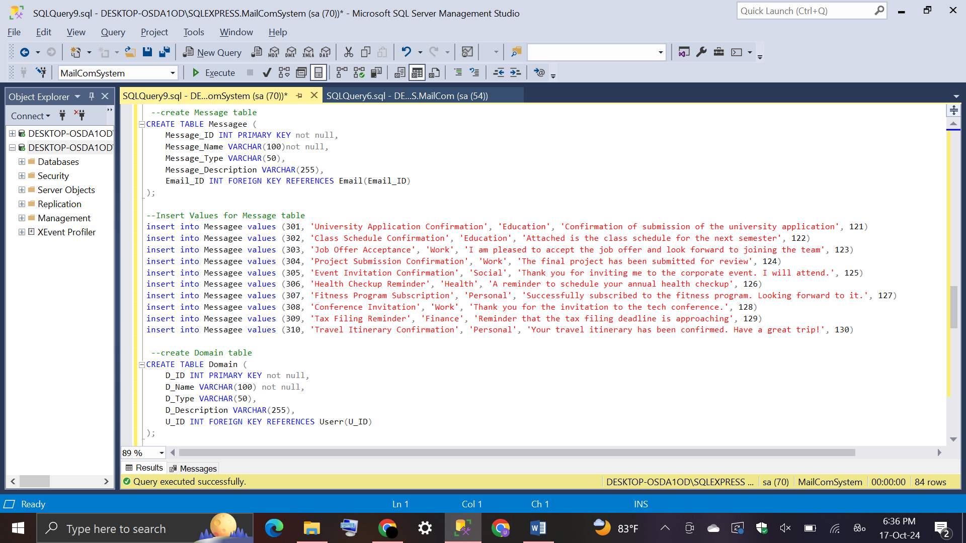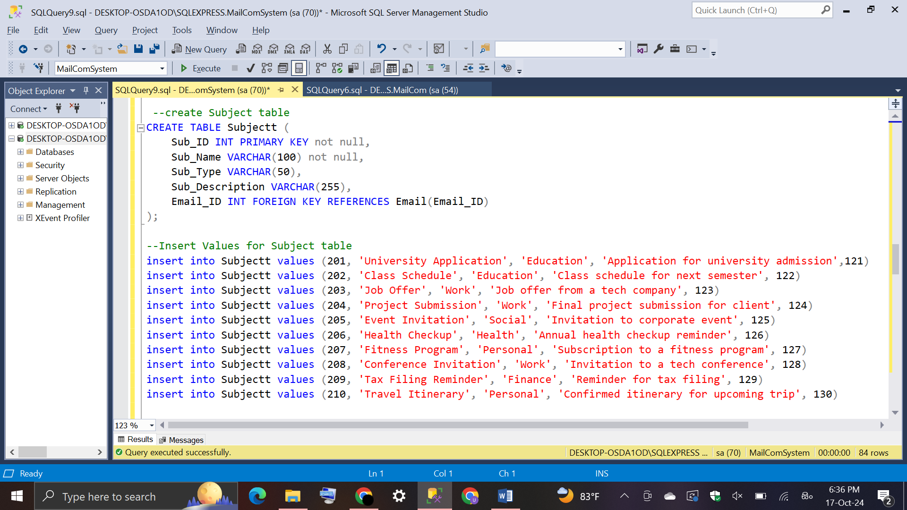

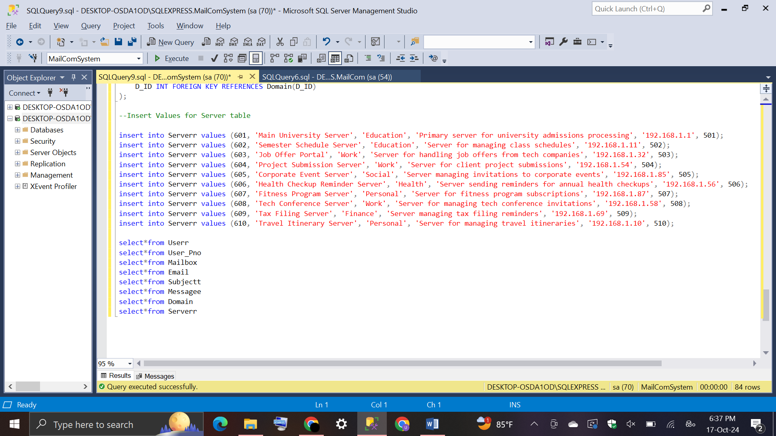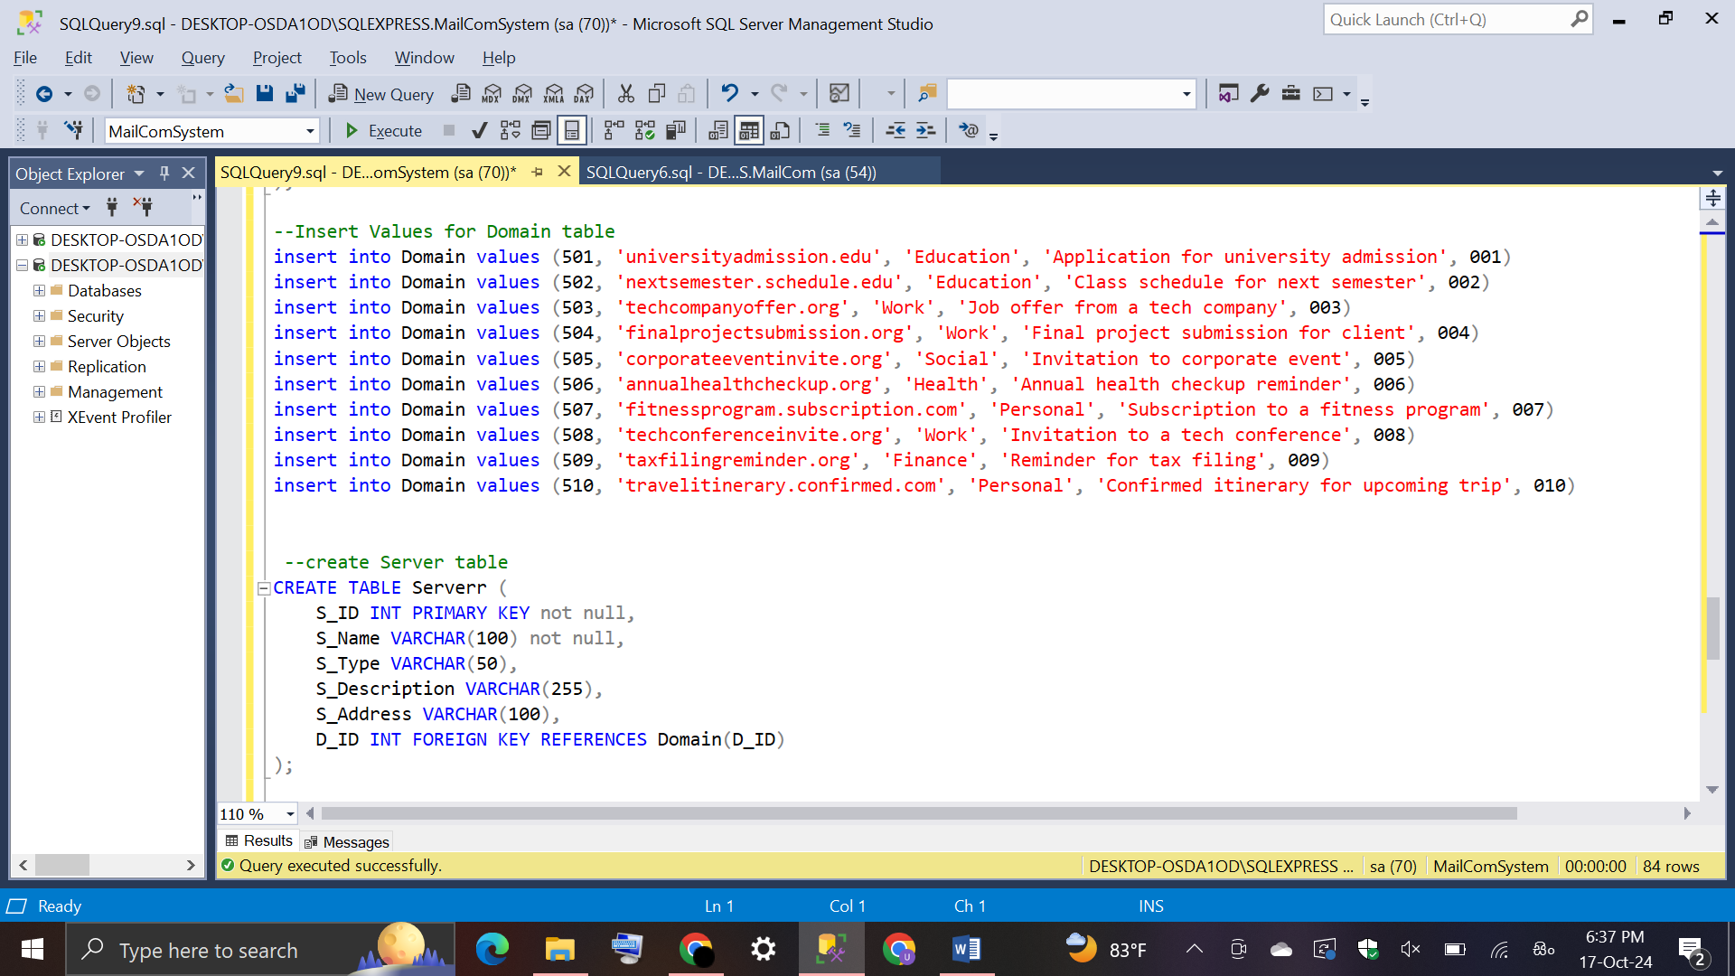

* 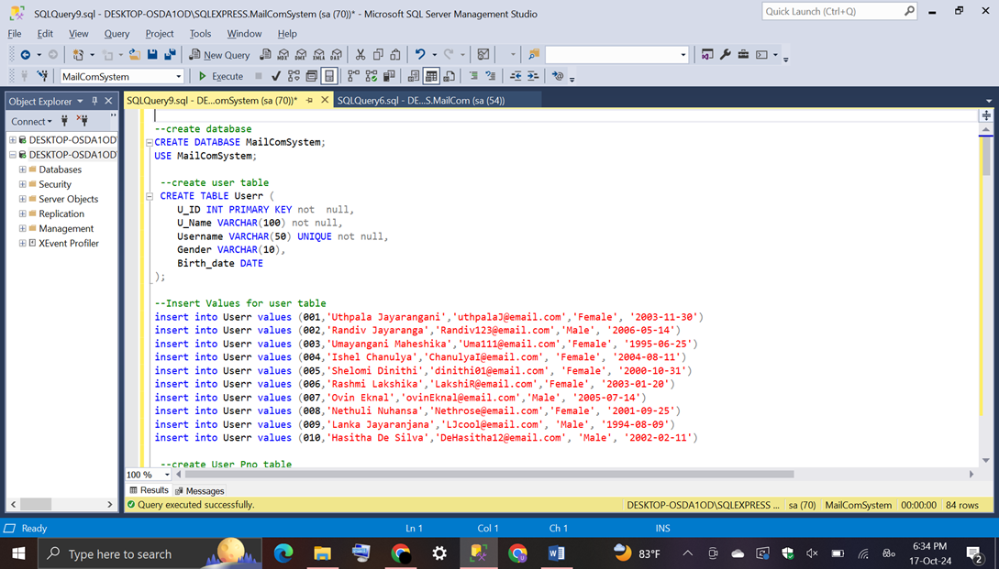**User Table**

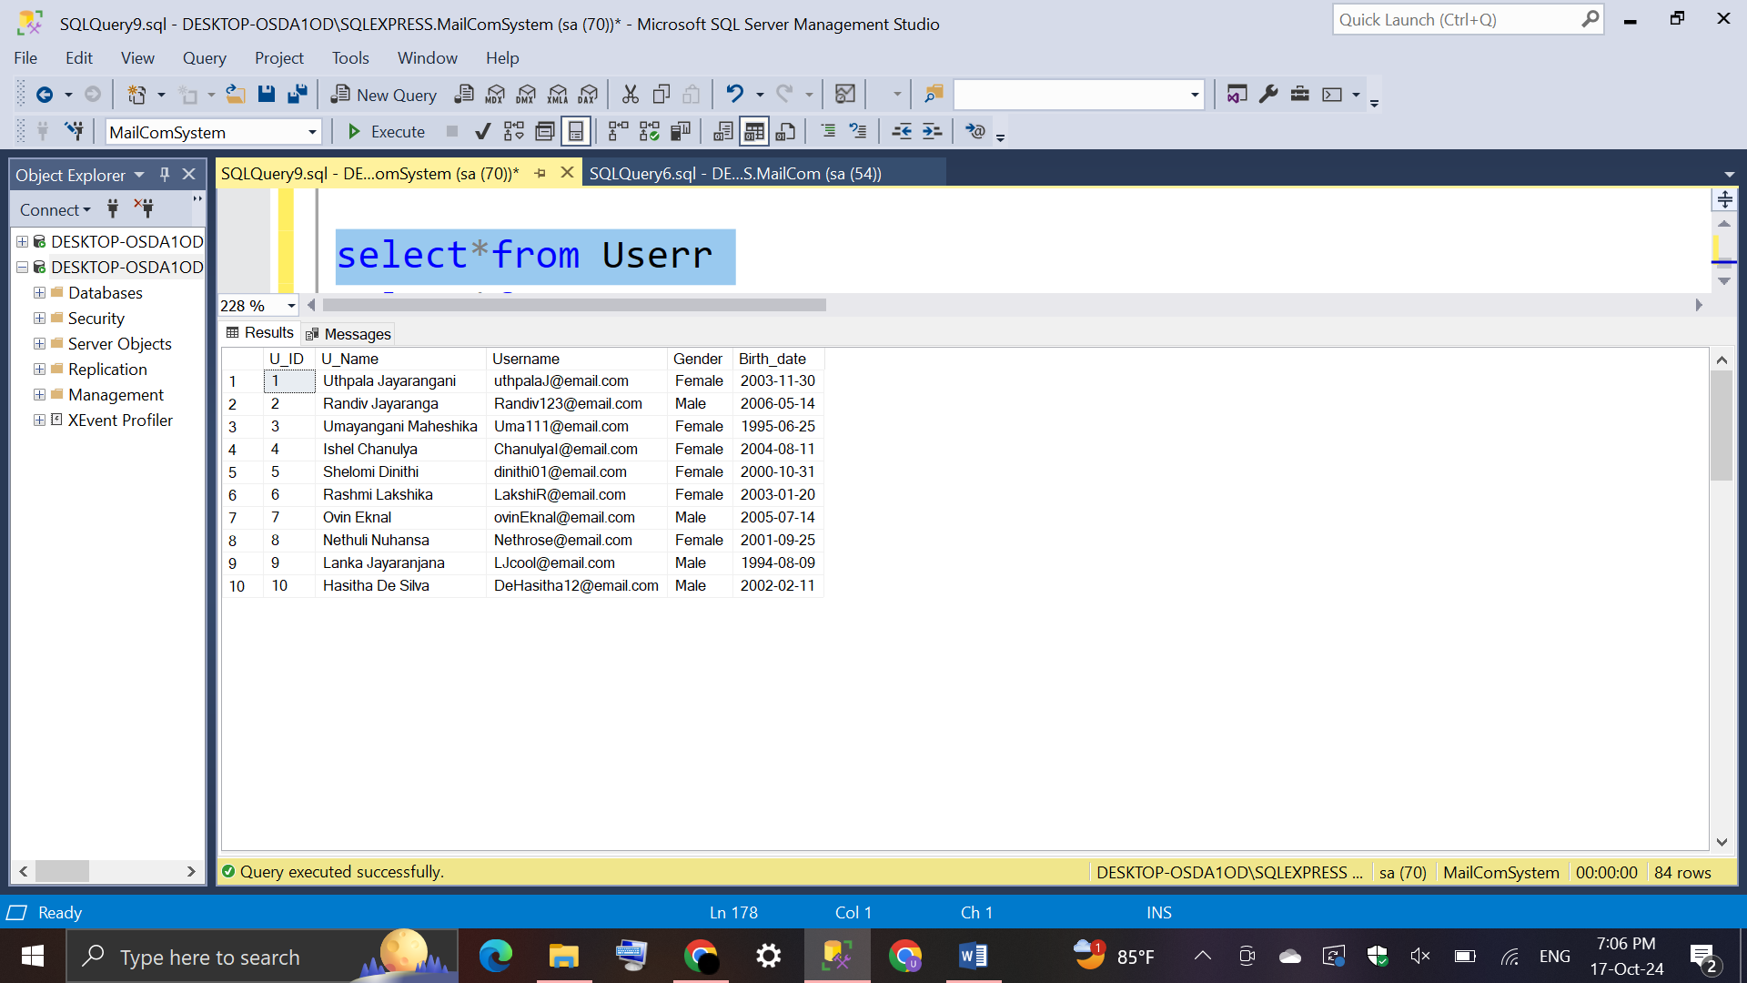Output:

* 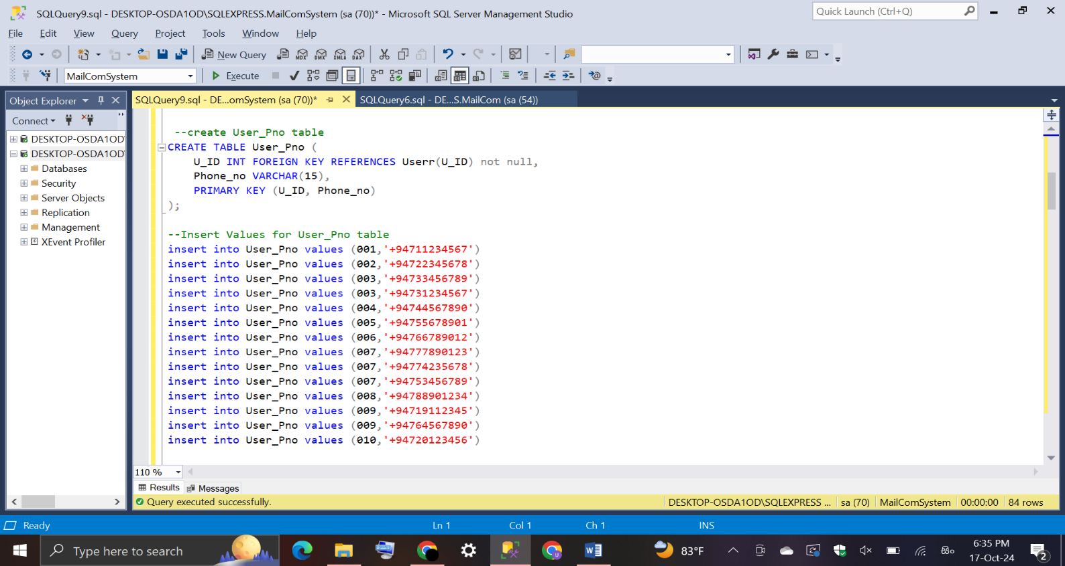**User_Pno Table**

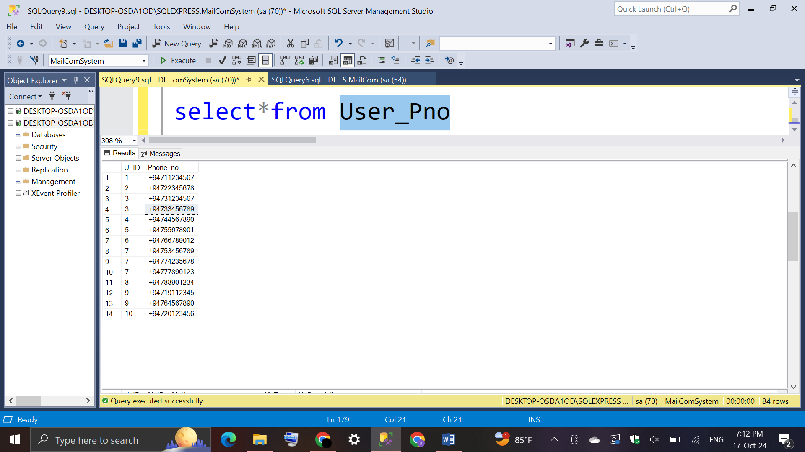Output:

* **Mailbox Table**

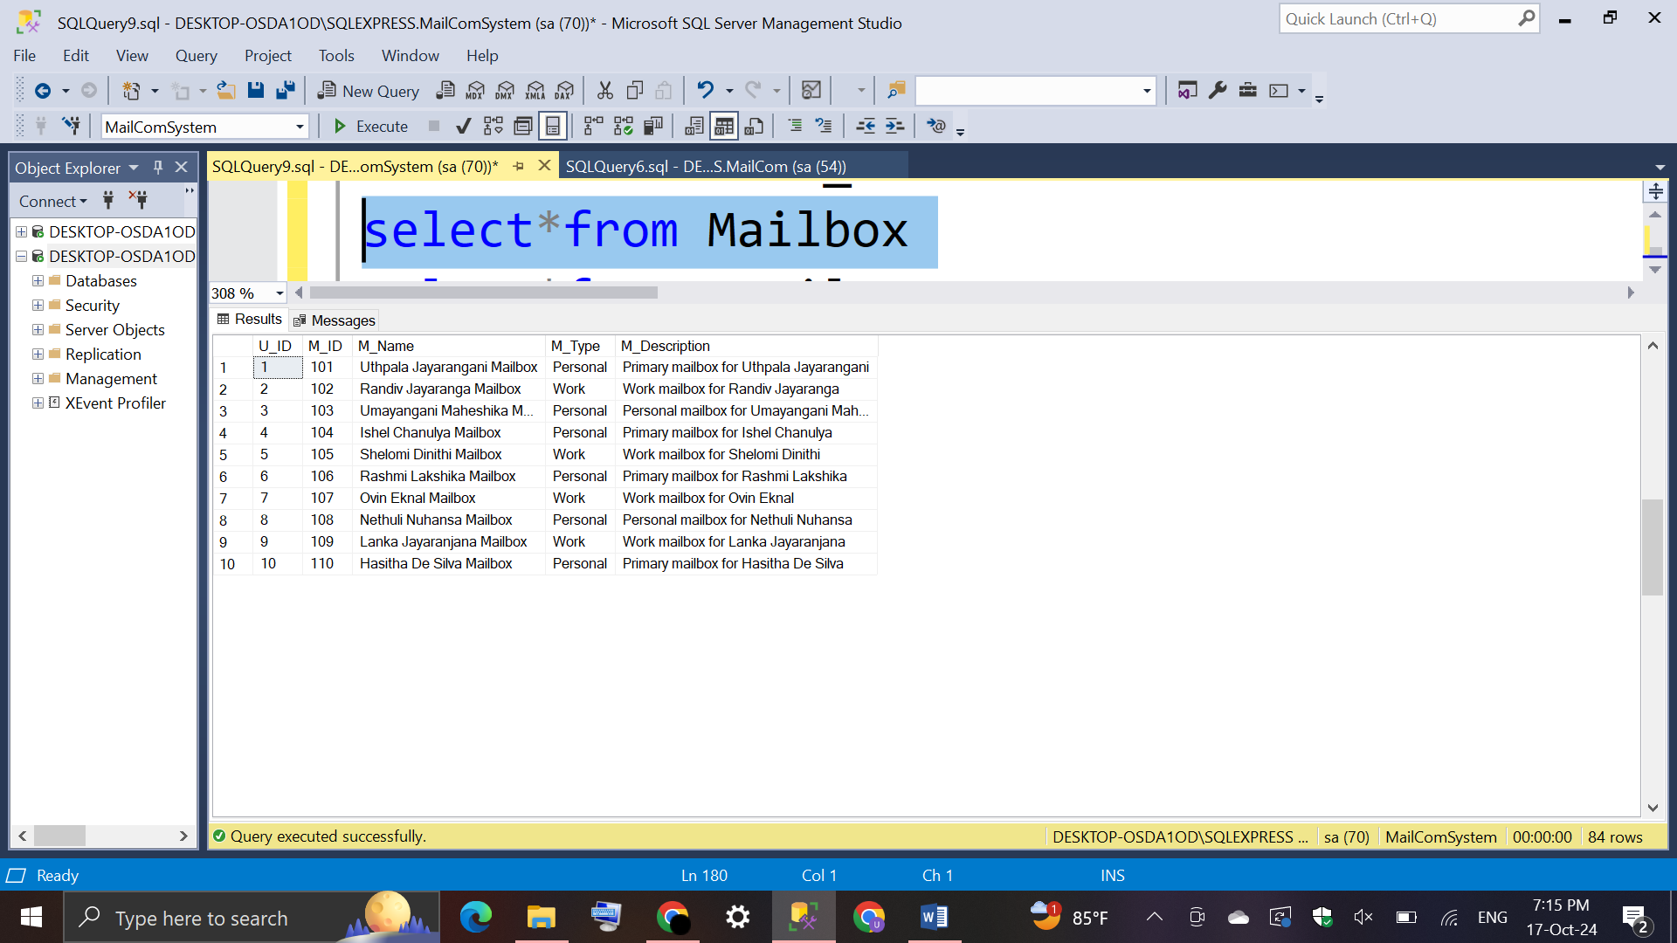Output:

* **Email Table**

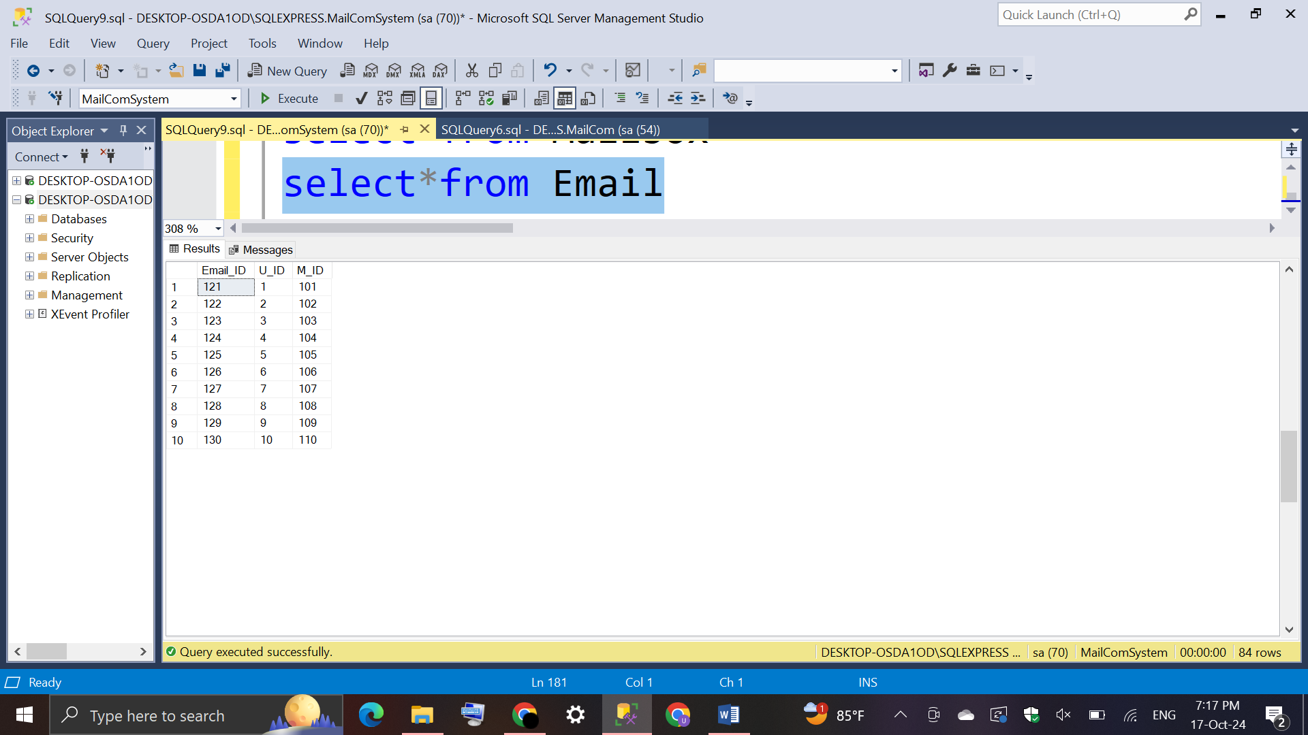Output:

* **Subject Table**

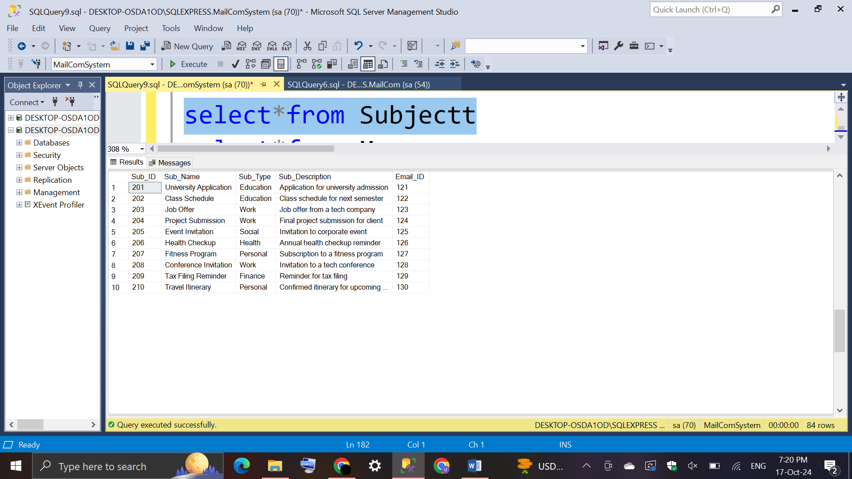Output:

* **Message Table**

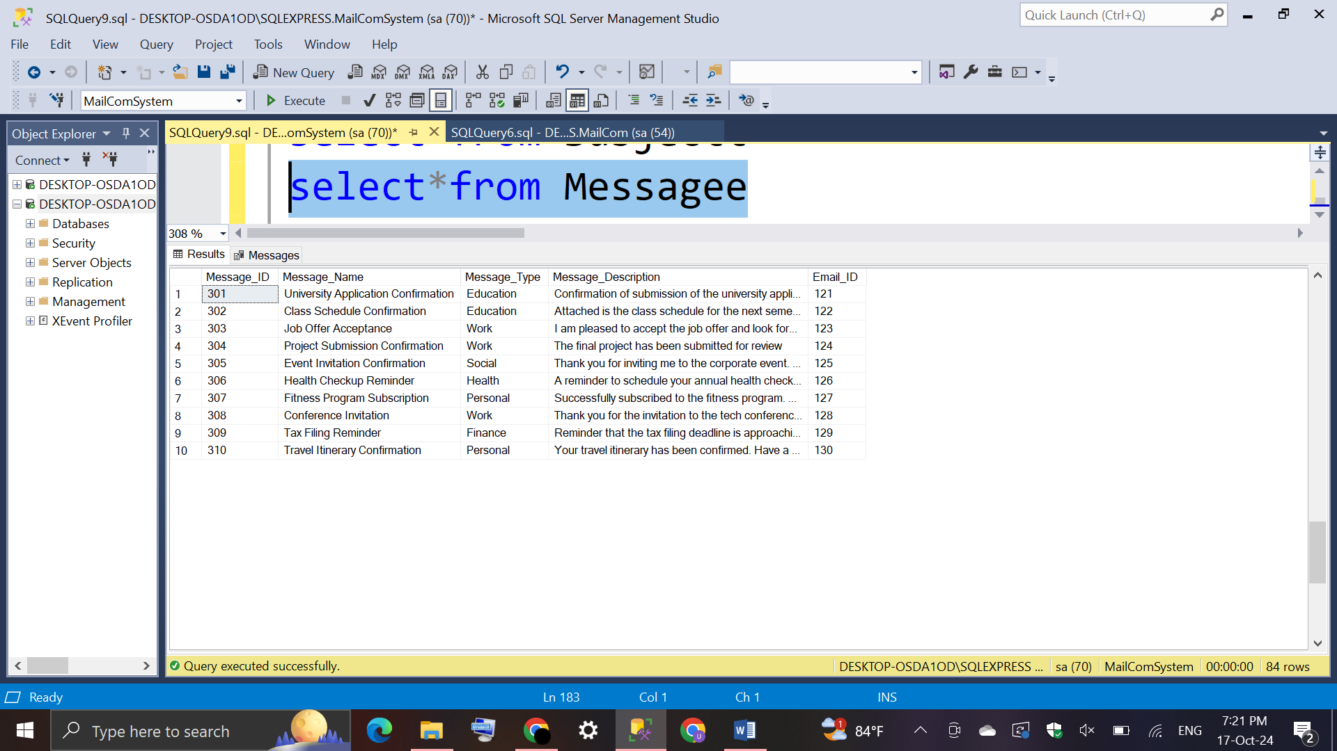Output:

* 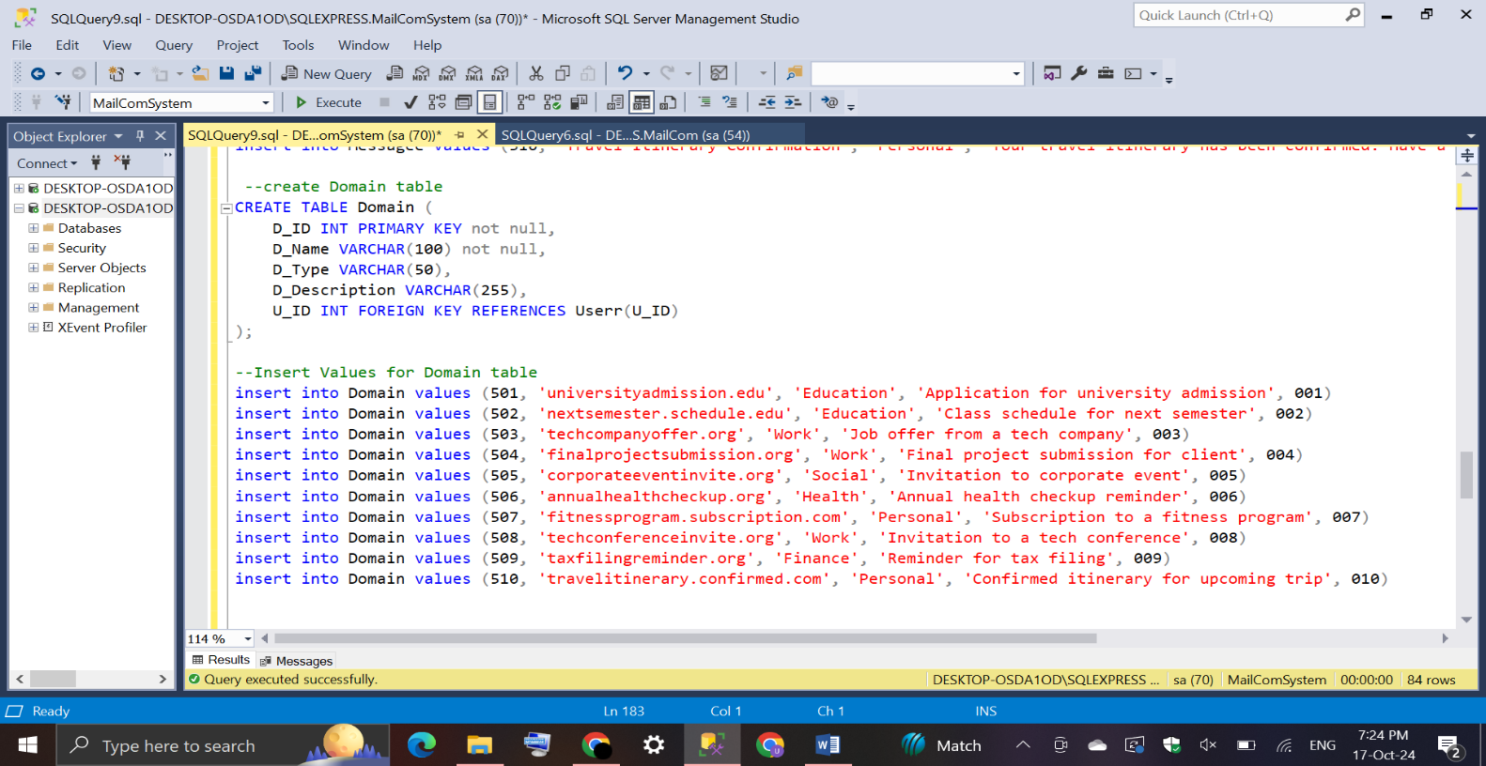**Domain Table**

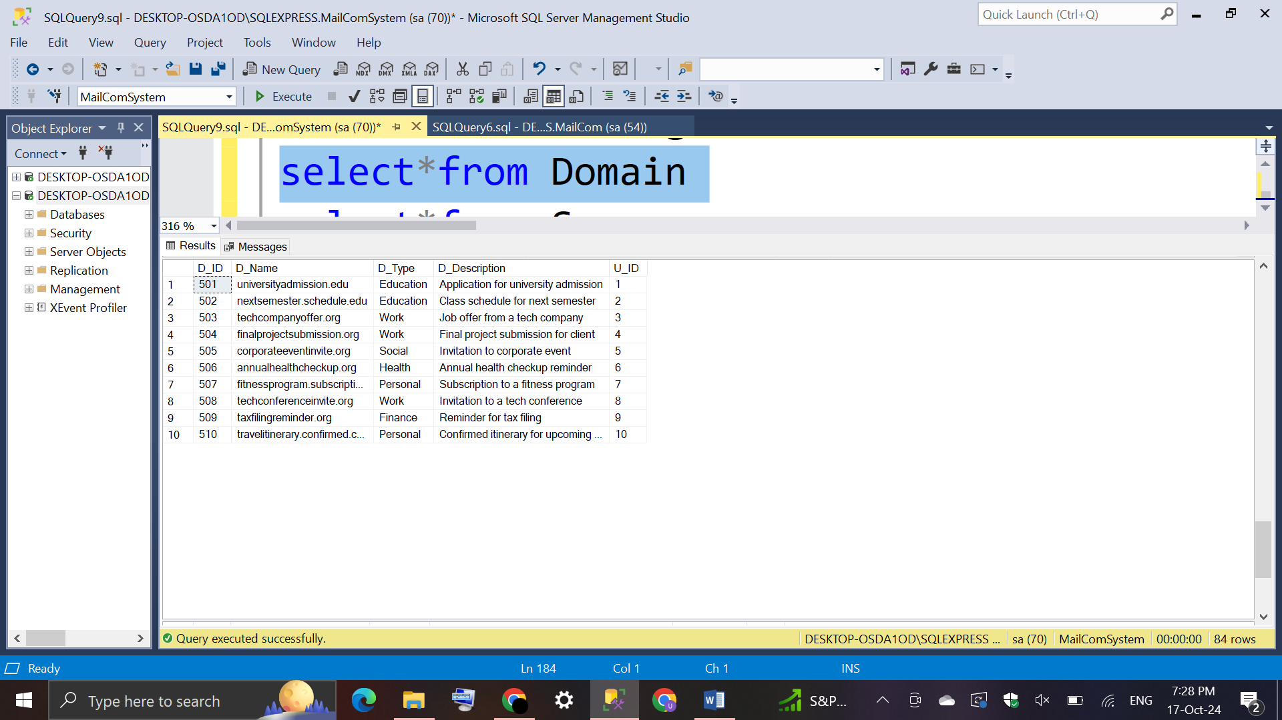Output:

* 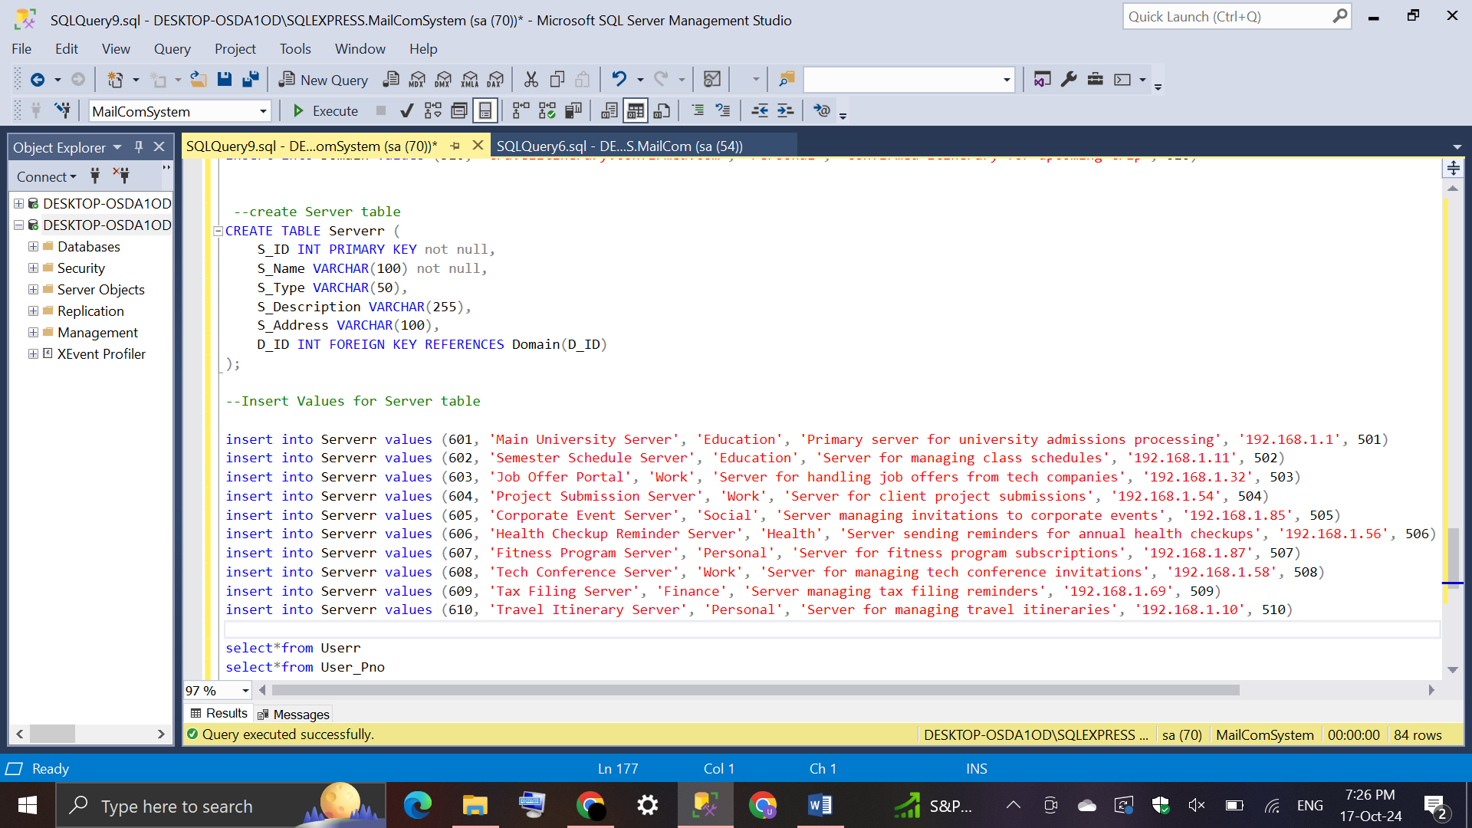**Server Table**

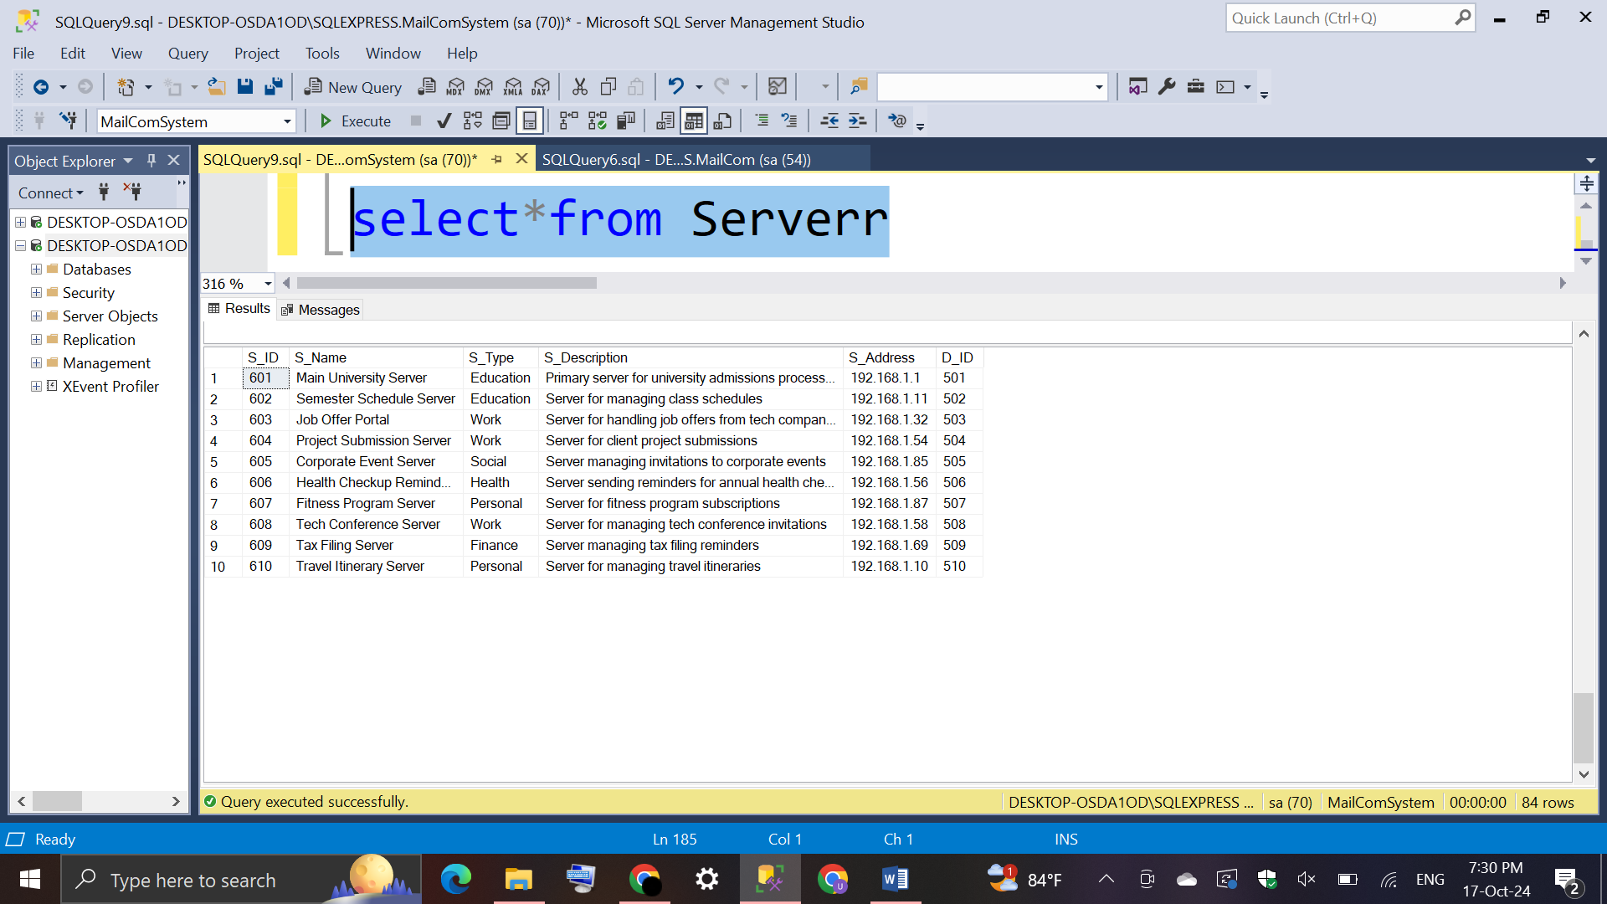 Output:

## **List of user details who has their birthdays in-between 1990 and 2000**.

## List of sent emails of a particular user.

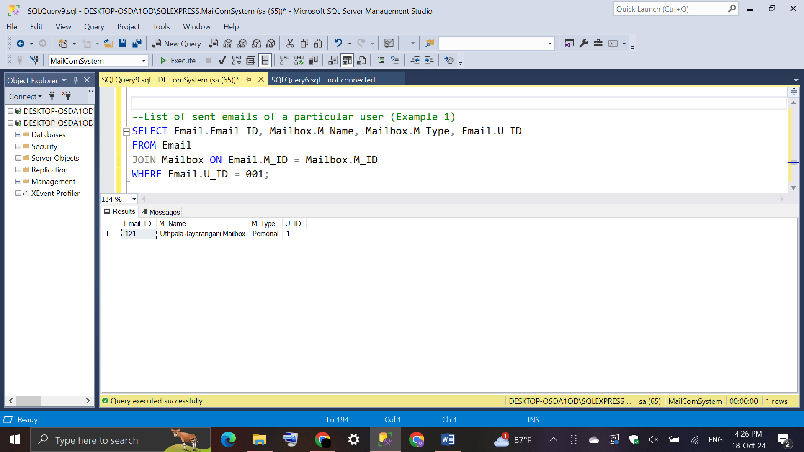**Example 1:** User with U_ID = 001

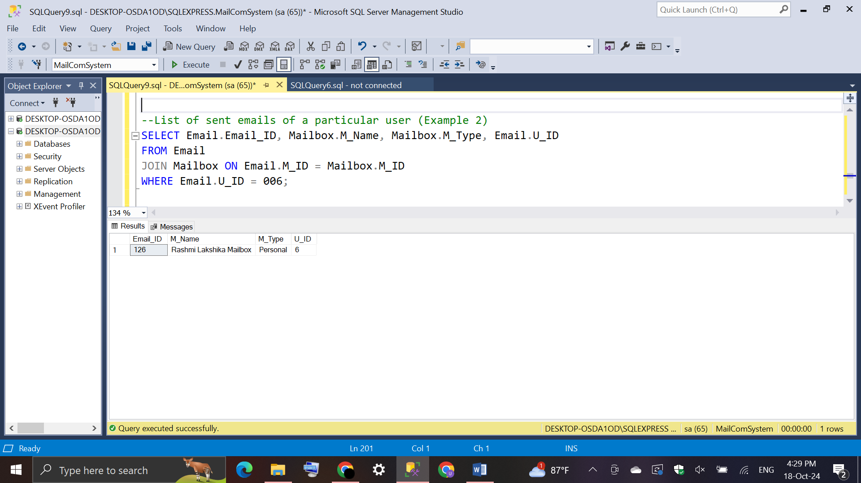**Example 2:** User with U_ID = 006

## **List of all the subject details and relevant message details**.

## List of registered user names (email addresses) for the particular domain.

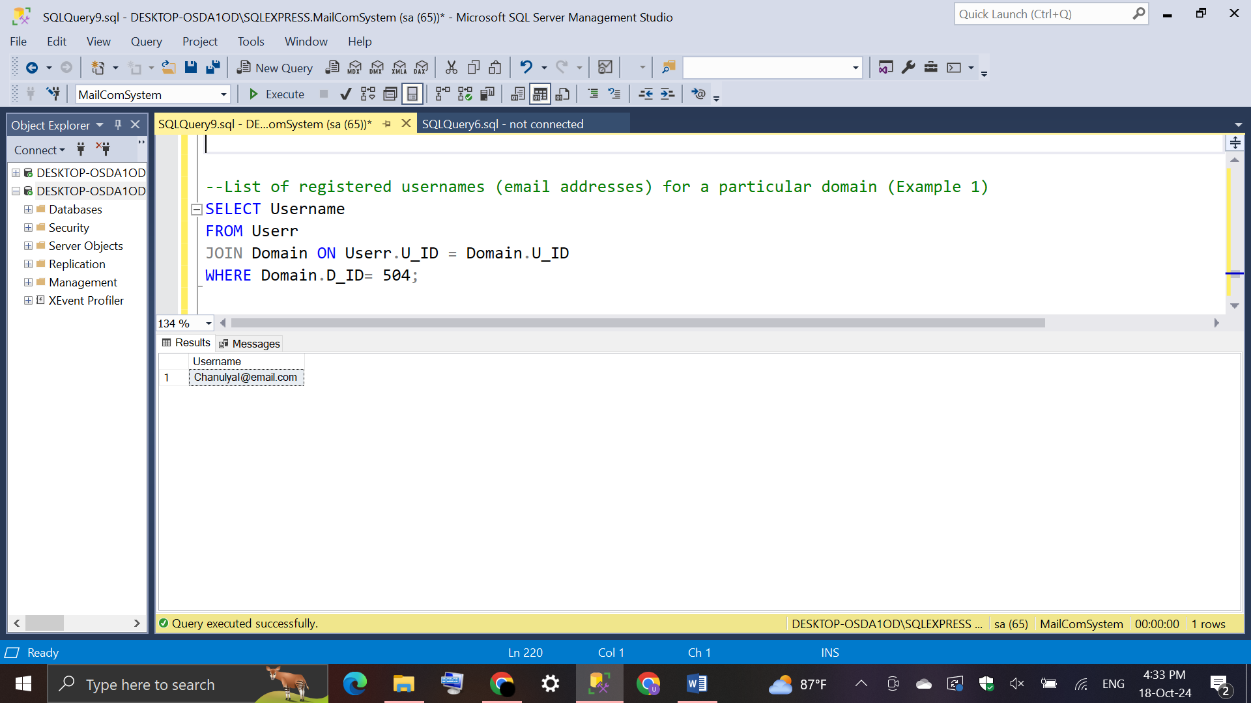**Example 1:** Domain with D_ID = 504

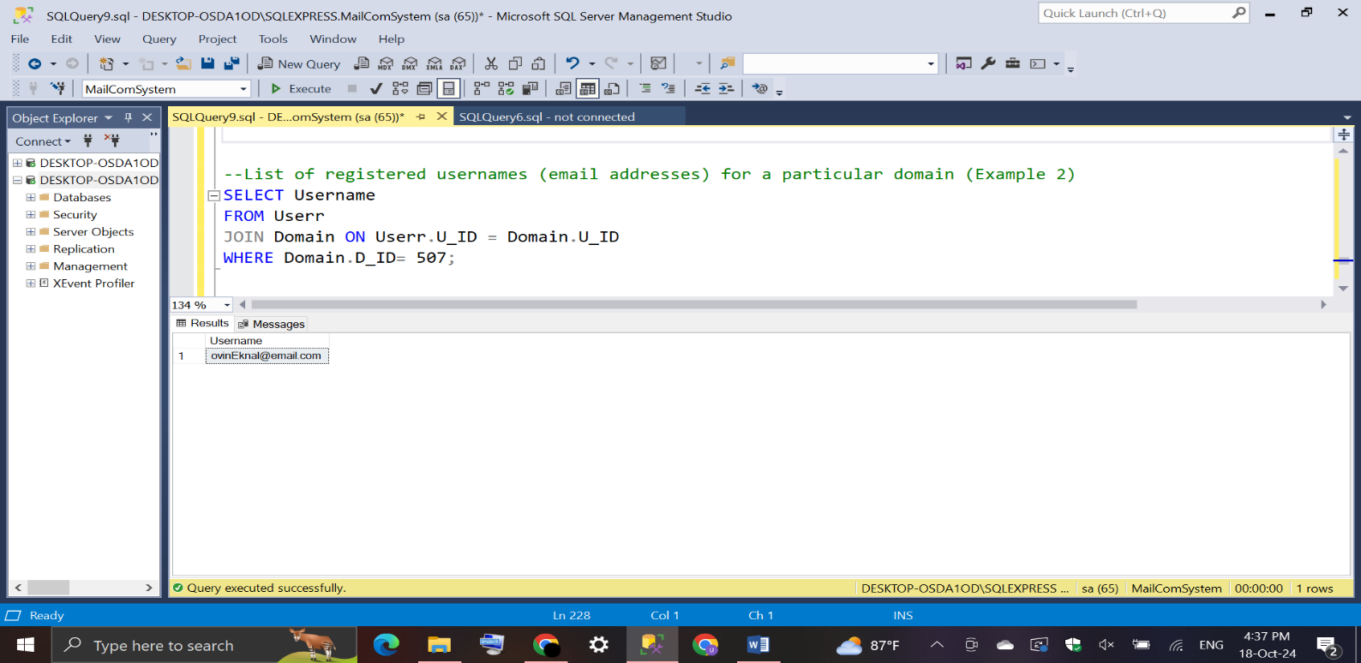**Example 2:** Domain with D_ID = 507

## Domain details with specific mail server details.

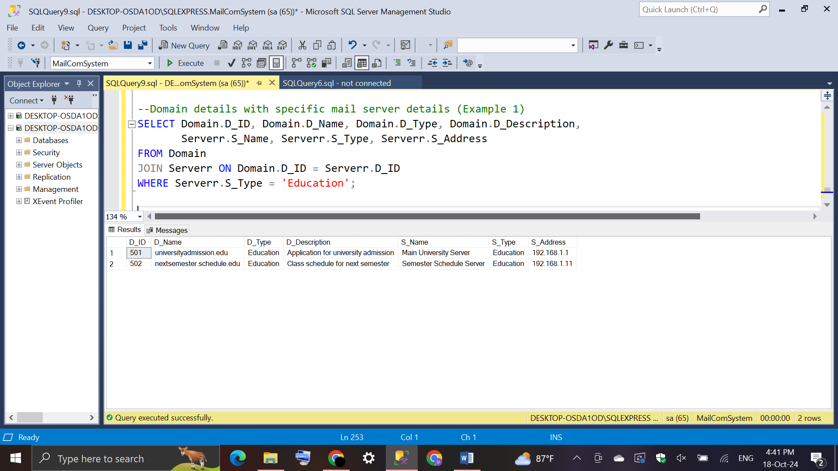**Example 1:** Server with S_Type = ‘Education’

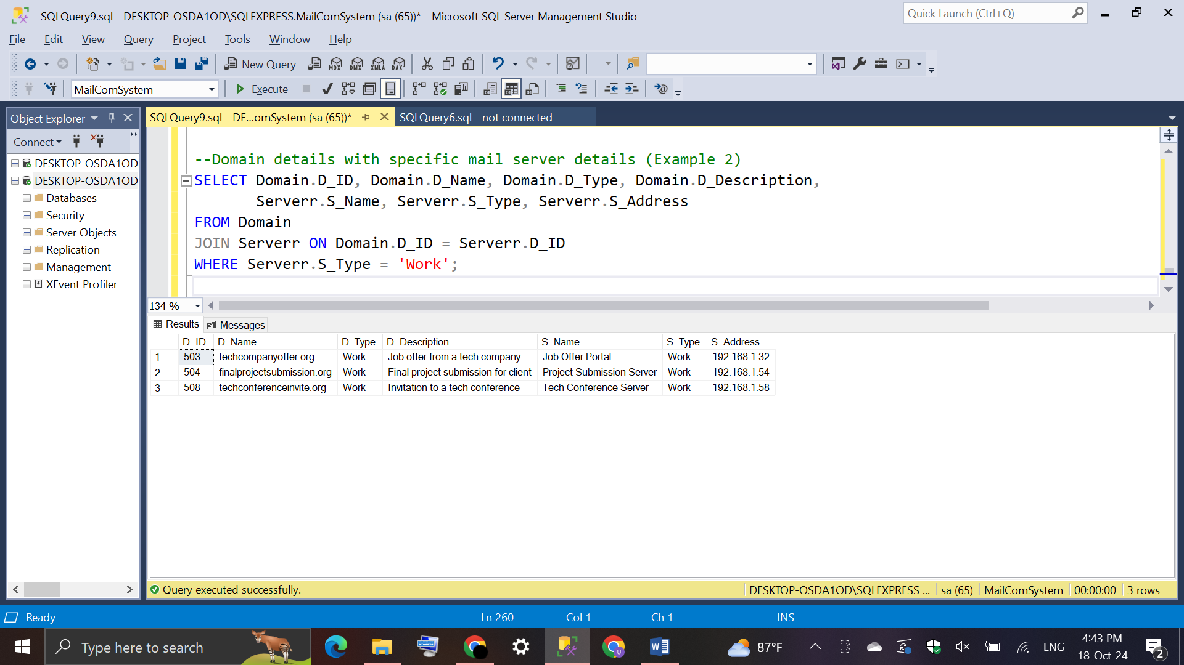**Example 2:** Server with S_Type = ‘Work’

## Test Strategy

* Manual Testing: All tests will be executed manually by running SQL scripts in the SQL client tool.
* Validation of Constraints: Ensure that the foreign key, primary key, and data integrity constraints are correctly enforced by attempting valid and invalid data entries.
* SQL Query Verification: Run specific queries to test the retrieval of data and verify that the correct results are returned.
* Data Integrity: Check the relationships between tables and ensure that the data adheres to the expected business rules and relationships.

**Tools**

MySQL Workbench or any SQL query execution tool.

## Test Plan

**Objective**

The objective of this test plan is to ensure the correct functioning of the MailComSystem database, focusing on data integrity, foreign key relationships, and the accuracy of SQL queries for the various entities, such as users, emails, mailboxes, domains, and servers.

**Scope**

The test plan will cover the following functionalities: Creation of tables and relationships between them. Insertion, selection, and retrieval of records. Validation of SQL queries like JOINs, SELECT, INSERT, and WHERE conditions. Ensuring data consistency across all tables.

**Test Plan**

|  |  |  |  |  |
| --- | --- | --- | --- | --- |
| No. | TC ID | TC Name | Steps | Result |
| 1 | TC01 | Create Database and Use Statement | Execute Create Database and execute Use Statement | Successfully CREATE DATABASE MailComSystem and Commands completed successfully message. |
| 2 | TC02 | Create User Table | Execute User Table and insert values into User Table | Successfully CREATE TABLE User and values inserted correctly. |
| 3 | TC03 | Query User details | Execute select*from User | Should return all records. |
| 4 | TC04 | Create User_Pno Table | Execute User_Pno Table and insert values into User_Pno Table | Successfully CREATE TABLE User_Pno and values inserted correctly. |
| 5 | TC05 | Query User_Pno details | Execute select*from User_Pno | Should return all records. |
| 6 | TC06 | Create Mailbox Table | Execute Mailbox Table and insert values into Mailbox Table | Successfully CREATE TABLE Mailbox and values inserted correctly. |
| 7 | TC07 | Query Mailbox details | Execute select*from Mailbox | Should return all records. |
| 8 | TC08 | Create Email Table | Execute Email Table and insert values into Email Table | Successfully CREATE TABLE Email and values inserted correctly. |
| 9 | TC09 | Query Email details | Execute select*from Email | Should return all records. |
| 10 | TC10 | Create Subject Table | Execute Subject Table and insert values into Subject Table | Successfully CREATE TABLE Subject and values inserted correctly. |
| 11 | TC11 | Query Subject details | Execute select*from Subject | Should return all records. |
| 12 | TC12 | Create Message Table | Execute Message Table and insert values into Message Table | Successfully CREATE TABLE Message and values inserted correctly. |
| 13 | TC13 | Query Message details | Execute select*from Message | Should return all records. |
| 14 | TC14 | Create Domain Table | Execute Domain Table and insert values into Domain Table | Successfully CREATE TABLE Domain and values inserted correctly. |
| 15 | TC15 | Query Domain details | Execute select*from Domain | Should return all records. |
| 16 | TC16 | Create Server Table | Execute Server Table and insert values into Server Table | Successfully CREATE TABLE Server and values inserted correctly. |
| 17 | TC17 | Query Server details | Execute select*from Server | Should return all records. |
| 18 | TC18 | Validate birthday range (between 1990 and 2000) | Execute SELECT *  FROM User  WHERE Birth_Date BETWEEN '1990-01-01' AND '2000-12-31'; | Returns correct users born between 1990-2000. |
| 19 | TC19 | List of sent emails of a particular user | Execute query for sent emails. | Should return emails belong to the specified user. |
| 20 | TC20 | List of all subject details and relevant message details | SELECT Subjectt.Sub_ID, Subjectt.Sub_Name,… JOIN Message ON Subjectt.Email_ID = Messagee.Email_ID; | Returns subjects and messages |
| 21 | TC21 | Registered usernames for a particular domain | Execute query for registered usernames. | Results match expected usernames for the domain. |
| 22 | TC22 | Domain details with specific mail server details | Execute query for domain and server details. | Should return correct data. Server details correspond to the expected domain. |

## Test Cases

|  |  |
| --- | --- |
| **Test Case ID** | TC01 |
| **Test Objective** | Ensure the Database creation. |
| **Test Data** | - |
| **Expected Result** | Database MailComSystem created. |
| **Actual Result** | Database MailComSystem created. |
| **Conclusion** | Database was successfully created. |
| **Screenshot** |  |

|  |  |
| --- | --- |
| **Test Case ID** | TC02.1 |
| **Test Objective** | Validate user table creation |
| **Test Data** | Table columns - U_ID, U_Name, Username, Gender, Birth_Date |
| **Expected Result** | Table User created successfully |
| **Actual Result** | Table User created successfully |
| **Conclusion** | User table created with all defined columns. |
| **Screenshot** |  |

|  |  |
| --- | --- |
| **Test Case ID** | TC02.2 |
| **Test Objective** | Check insertion of user table |
| **Test Data** | Values such as   * 001,'Uthpala Jayarangani','uthpalaJ@email.com','Female', '2003-11-30' * 002,'Randiv Jayaranga','Randiv123@email.com','Male', '2006-05-14' * 003,'Umayangani Maheshika','Uma111@email.com','Female', '1995-06-25' |
| **Expected Result** | Values insert successfully. |
| **Actual Result** | Values insert successfully. |
| **Conclusion** | All values were inserted into the User table correctly. |
| **Screenshot** |  |

|  |  |
| --- | --- |
| **Test Case ID** | TC03 |
| **Test Objective** | Query and validate users |
| **Test Data** | Query results for select*from User |
| **Expected Result** | Should return all user recodes. |
| **Actual Result** | Should return all user recodes. |
| **Conclusion** | Query returned all records from the User table. |
| **Screenshot** |  |

|  |  |
| --- | --- |
| **Test Case ID** | TC04.1 |
| **Test Objective** | Create User_Pno table and validate |
| **Test Data** | Table columns- U_ID, Phone_no |
| **Expected Result** | Table User_Pno created successfully |
| **Actual Result** | Table User_Pno created successfully |
| **Conclusion** | User_Pno table was created with all defined columns. |
| **Screenshot** |  |

|  |  |
| --- | --- |
| **Test Case ID** | TC04.2 |
| **Test Objective** | Validate phone number insertion |
| **Test Data** | Values like   * 001,'+94711234567' * 002,'+94722345678' * 003,'+94733456789' |
| **Expected Result** | Phone numbers inserted successfully. |
| **Actual Result** | Phone numbers inserted successfully. |
| **Conclusion** | Phone numbers were inserted successfully in User_Pno table. |
| **Screenshot** |  |

|  |  |
| --- | --- |
| **Test Case ID** | TC5 |
| **Test Objective** | Query and validate User_Pno |
| **Test Data** | Query results for select*from User_Pno |
| **Expected Result** | Should return all User_Pno recodes. |
| **Actual Result** | Should return all User_Pno recodes. |
| **Conclusion** | Query returned all records from the User_Pno table. |
| **Screenshot** |  |

|  |  |
| --- | --- |
| **Test Case ID** | TC06.1 |
| **Test Objective** | Create Mailbox table and validate |
| **Test Data** | Table columns- U_ID, M_ID, M_Name, M_Type, M_Description |
| **Expected Result** | Table Mailbox created successfully |
| **Actual Result** | Table Mailbox created successfully |
| **Conclusion** | Mailbox table was created with all defined columns. |
| **Screenshot** |  |

|  |  |
| --- | --- |
| **Test Case ID** | TC06.2 |
| **Test Objective** | Validate Mailbox insertion |
| **Test Data** | Values like   * 001,101,'Uthpala Jayarangani Mailbox', 'Personal', 'Primary mailbox for Uthpala Jayarangani' * 002,102,'Randiv Jayaranga Mailbox', 'Work', 'Work mailbox for Randiv Jayaranga' * 003,103,'Umayangani Maheshika Mailbox', 'Personal', 'Personal mailbox for Umayangani Maheshika' |
| **Expected Result** | Values insert successfully. |
| **Actual Result** | Values insert successfully. |
| **Conclusion** | All values were inserted into the Mailbox table correctly. |
| **Screenshot** |  |

|  |  |
| --- | --- |
| **Test Case ID** | TC07 |
| **Test Objective** | Query and validate Mailbox |
| **Test Data** | Query results for select*from Mailbox |
| **Expected Result** | Should return all Mailbox recodes. |
| **Actual Result** | Should return all Mailbox recodes. |
| **Conclusion** | Query returned all records from the Mailbox table. |
| **Screenshot** |  |

|  |  |
| --- | --- |
| **Test Case ID** | TC08.1 |
| **Test Objective** | Create Email table and validate |
| **Test Data** | Table columns- Email_ID, U_ID, M_ID |
| **Expected Result** | Table Email created successfully |
| **Actual Result** | Table Email created successfully |
| **Conclusion** | Email table was created with all defined columns. |
| **Screenshot** |  |

|  |  |
| --- | --- |
| **Test Case ID** | TC08.2 |
| **Test Objective** | Check insertion of Email table |
| **Test Data** | Values such as   * 121,001,101 * 122,002,102 * 123,003,103 |
| **Expected Result** | Values insert successfully. |
| **Actual Result** | Values insert successfully. |
| **Conclusion** | All values were inserted into the Email table correctly. |
| **Screenshot** |  |

|  |  |
| --- | --- |
| **Test Case ID** | TC09 |
| **Test Objective** | Query and validate Email |
| **Test Data** | Query results for select*from Email |
| **Expected Result** | Should return all Email recodes. |
| **Actual Result** | Should return all Email recodes. |
| **Conclusion** | Query returned all records from the Mailbox table. |
| **Screenshot** |  |

|  |  |
| --- | --- |
| **Test Case ID** | TC10.1 |
| **Test Objective** | Create Message table and validate |
| **Test Data** | Table columns- Message_ID, Message_Name, Message_Type, Message_Description, Email_ID |
| **Expected Result** | Table Message created successfully |
| **Actual Result** | Table Message created successfully |
| **Conclusion** | Message table was created with all defined columns. |
| **Screenshot** |  |

|  |  |
| --- | --- |
| **Test Case ID** | TC10.2 |
| **Test Objective** | Check insertion of Message table |
| **Test Data** | Values such as   * 301, 'University Application Confirmation', 'Education', 'Confirmation of submission of the university application', 121 * 302, 'Class Schedule Confirmation', 'Education', 'Attached is the class schedule for the next semester', 122 * 303, 'Job Offer Acceptance', 'Work', 'I am pleased to accept the job offer and look forward to joining the team', 123 |
| **Expected Result** | Values insert successfully. |
| **Actual Result** | Values insert successfully. |
| **Conclusion** | All values were inserted into the Message table correctly. |
| **Screenshot** |  |

|  |  |
| --- | --- |
| **Test Case ID** | TC11 |
| **Test Objective** | Query and validate Message |
| **Test Data** | Query results for select*from Message |
| **Expected Result** | Should return all Message recodes. |
| **Actual Result** | Should return all Message recodes. |
| **Conclusion** | Query returned all records from the Message table. |
| **Screenshot** |  |

|  |  |
| --- | --- |
| **Test Case ID** | TC12.1 |
| **Test Objective** | Create Subject table and validate |
| **Test Data** | Table columns- Sub_ID, Sub_Name, Sub_Type, Sub_Description, Email_ID |
| **Expected Result** | Table Subject created successfully |
| **Actual Result** | Table Subject created successfully |
| **Conclusion** | Subject table was created with all defined columns. |
| **Screenshot** |  |

|  |  |
| --- | --- |
| **Test Case ID** | TC12.2 |
| **Test Objective** | Check insertion of Subject table |
| **Test Data** | Values such as   * 201, 'University Application', 'Education', 'Application for university admission',121 * 202, 'Class Schedule', 'Education', 'Class schedule for next semester', 122 * 203, 'Job Offer', 'Work', 'Job offer from a tech company', 123 |
| **Expected Result** | Values insert successfully. |
| **Actual Result** | Values insert successfully. |
| **Conclusion** | All values were inserted into the Subject table correctly. |
| **Screenshot** |  |

|  |  |
| --- | --- |
| **Test Case ID** | TC13 |
| **Test Objective** | Query and validate Subject |
| **Test Data** | Query results for select*from Subject |
| **Expected Result** | Should return all Subject recodes. |
| **Actual Result** | Should return all Subject recodes. |
| **Conclusion** | Query returned all records from the Subject table. |
| **Screenshot** |  |

|  |  |
| --- | --- |
| **Test Case ID** | TC14.1 |
| **Test Objective** | Create Domain table and validate |
| **Test Data** | Table columns- D_ID, D_Name, D_Type, D_Description, U_ID |
| **Expected Result** | Table Domain created successfully |
| **Actual Result** | Table Domain created successfully |
| **Conclusion** | Domain table was created with all defined columns. |
| **Screenshot** |  |

|  |  |
| --- | --- |
| **Test Case ID** | TC14.2 |
| **Test Objective** | Check insertion of Domain table |
| **Test Data** | Values such as   * 501, 'universityadmission.edu', 'Education', 'Application for university admission', 001 * 502, 'nextsemester.schedule.edu', 'Education', 'Class schedule for next semester', 002 * 503, 'techcompanyoffer.org', 'Work', 'Job offer from a tech company', 003 |
| **Expected Result** | Values insert successfully. |
| **Actual Result** | Values insert successfully. |
| **Conclusion** | All values were inserted into the Domain table correctly. |
| **Screenshot** |  |

|  |  |
| --- | --- |
| **Test Case ID** | TC15 |
| **Test Objective** | Query and validate Domain |
| **Test Data** | Query results for select*from Domain |
| **Expected Result** | Should return all Domain recodes. |
| **Actual Result** | Should return all Domain recodes. |
| **Conclusion** | Query returned all records from the Domain table. |
| **Screenshot** |  |

|  |  |
| --- | --- |
| **Test Case ID** | TC16.1 |
| **Test Objective** | Create Server table and validate |
| **Test Data** | Table columns- S_ID, S_Name, S_Type, S_Description, S_Address, D_ID |
| **Expected Result** | Table Server created successfully |
| **Actual Result** | Table Server created successfully |
| **Conclusion** | Server table was created with all defined columns. |
| **Screenshot** |  |

|  |  |
| --- | --- |
| **Test Case ID** | TC16.2 |
| **Test Objective** | Check insertion of Server table |
| **Test Data** | Values such as   * 601, 'Main University Server', 'Education', 'Primary server for university admissions processing', '192.168.1.1', 501 * 602, 'Semester Schedule Server', 'Education', 'Server for managing class schedules', '192.168.1.11', 502 * 603, 'Job Offer Portal', 'Work', 'Server for handling job offers from tech companies', '192.168.1.32', 503 |
| **Expected Result** | Values insert successfully. |
| **Actual Result** | Values insert successfully. |
| **Conclusion** | All values were inserted into the Server table correctly. |
| **Screenshot** |  |

|  |  |
| --- | --- |
| **Test Case ID** | TC17 |
| **Test Objective** | Query and validate Server |
| **Test Data** | Query results for select*from Server |
| **Expected Result** | Should return all Server recodes. |
| **Actual Result** | Should return all Server recodes. |
| **Conclusion** | Query returned all records from the Server table. |
| **Screenshot** |  |

|  |  |
| --- | --- |
| **Test Case ID** | TC18 |
| **Test Objective** | Validate birthday range |
| **Test Data** | Query result for  SELECT *  FROM User  WHERE Birth_Date BETWEEN '1990-01-01' AND '2000-12-31'; |
| **Expected Result** | Return users born between 1990 and 2000. |
| **Actual Result** | Return users born between 1990 and 2000. |
| **Conclusion** | Users born between 1990 and 2000 were retrieved. |
| **Screenshot** |  |

|  |  |
| --- | --- |
| **Test Case ID** | TC19.1 |
| **Test Objective** | List of sent emails of a particular user (Example 1) |
| **Test Data** | Query result for  SELECT Email.Email_ID, Mailbox.M_Name, Mailbox.M_Type, Email.U_ID  FROM Email  JOIN Mailbox ON Email.M_ID = Mailbox.M_ID  WHERE Email.U_ID = 001; |
| **Expected Result** | Return all emails foe User ID 001. |
| **Actual Result** | Return all emails foe User ID 001. |
| **Conclusion** | Emails for User ID 001 were retrieved correctly. |
| **Screenshot** |  |

|  |  |
| --- | --- |
| **Test Case ID** | TC19.2 |
| **Test Objective** | List of sent emails of a particular user (Example 2) |
| **Test Data** | Query result for  SELECT Email.Email_ID, Mailbox.M_Name, Mailbox.M_Type, Email.U_ID  FROM Email  JOIN Mailbox ON Email.M_ID = Mailbox.M_ID  WHERE Email.U_ID = 006; |
| **Expected Result** | Return all emails foe User ID 006. |
| **Actual Result** | Return all emails foe User ID 006. |
| **Conclusion** | Emails for User ID 001 were retrieved correctly. |
| **Screenshot** |  |

|  |  |
| --- | --- |
| **Test Case ID** | TC20 |
| **Test Objective** | List of all subject details and relevant message details ist of sent emails of a particular user |
| **Test Data** | Query to join subject and message data |
| **Expected Result** | Return all subjects with corresponding messages. |
| **Actual Result** | Return all subjects with corresponding messages. |
| **Conclusion** | Subject and message join returned correct details. |
| **Screenshot** |  |

|  |  |
| --- | --- |
| **Test Case ID** | TC21.1 |
| **Test Objective** | Validate Username with Domain (Example 1) |
| **Test Data** | Query:  SELECT Username  FROM User  JOIN Domain ON Userr.U_ID = Domain.U_ID  WHERE Domain.D_ID= 504; |
| **Expected Result** | Return usernames for Domain ID 504. |
| **Actual Result** | Return usernames for Domain ID 504. |
| **Conclusion** | Query returned correct usernames for domain 504. |
| **Screenshot** |  |

|  |  |
| --- | --- |
| **Test Case ID** | TC21.2 |
| **Test Objective** | Validate Username with Domain (Example 2) |
| **Test Data** | Query:  SELECT Username  FROM Userr  JOIN Domain ON Userr.U_ID = Domain.U_ID  WHERE Domain.D_ID= 507; |
| **Expected Result** | Return usernames for Domain ID 507. |
| **Actual Result** | Return usernames for Domain ID 507. |
| **Conclusion** | Query returned correct usernames for domain 504. |
| **Screenshot** |  |

|  |  |
| --- | --- |
| **Test Case ID** | TC22.1 |
| **Test Objective** | Validate Domain details with specific mail server details (Example 1) |
| **Test Data** | Query:  SELECT Domain.D_ID, Domain.D_Name, Domain.D_Type, Domain.D_Description,  Serverr.S_Name, Serverr.S_Type, Serverr.S_Address  FROM Domain  JOIN Serverr ON Domain.D_ID = Serverr.D_ID  WHERE Serverr.S_Type = 'Education'; |
| **Expected Result** | Return domain details and server details for server type Education. |
| **Actual Result** | Return domain details and server details for server type Education. |
| **Conclusion** | Server and domain details for ‘Education’ server type returned. |
| **Screenshot** |  |

|  |  |
| --- | --- |
| **Test Case ID** | TC22.2 |
| **Test Objective** | Validate Domain details with specific mail server details (Example 2) |
| **Test Data** | Query:  SELECT Domain.D_ID, Domain.D_Name, Domain.D_Type, Domain.D_Description,  Serverr.S_Name, Serverr.S_Type, Serverr.S_Address  FROM Domain  JOIN Serverr ON Domain.D_ID = Serverr.D_ID  WHERE Serverr.S_Type = 'Work'; |
| **Expected Result** | Return domain details and server details for server type Work. |
| **Actual Result** | Return domain details and server details for server type Work. |
| **Conclusion** | Server and domain details for ‘Work’ server type returned. |
| **Screenshot** |  |